# Life Cycle Plan (LCP)

**NICE**

**TEAM 7**

Deborah Baker – Assistant PM, QFP (Team & Web Req), IIV & V, Team Website Admin

Antonis Papantoniou – Project Manager (PM), Prototyper, Software Architect, Feasibility Analyst

Runxuan Wei – Prototyper, Life Cycle Planner

Weijiang Dang – Developer, Operational Concept Engineer

King Lun Au – Developer, Life Cycle Planner

Dhananjay Nakrani – Prototyper, Operational Concept Engineer, Team Website Admin

### 

**Nov 26, 2015**

# Version History

| Date | Author | Version | Changes made | Rationale |
| --- | --- | --- | --- | --- |
| 10/15/15 | WRX | 1.0 | • | Created SSAD and added  section 1,2,3 |
| 12/03/15 | WRX | 2.0 | • Updated the artifact of developmental phrase  • Updated a new Gantt chart  • Modified the methods, tools, and facilities  • Added Iteration plan | Added section 6 |

# Table of Contents

Life Cycle Plan (LCP) i

Version History ii

Table of Contents iii

Table of Tables v

Table of Figures vi

1. Introduction 1

1.1 Purpose of the LCP 1

1.2 Status of the LCP 1

1.3 Assumptions 1

2. Milestones and Products 2

2.1 Overall Strategy 2

2.2 Project Deliverables 3

3. Responsibilities 8

3.1 Project-specific stakeholder’s responsibilities 8

3.2 Responsibilities by Phase 8

3.3 Skills 10

4. Approach 12

4.1 Monitoring and Control 12

4.2 Methods, Tools and Facilities 12

5. Resources 13

6. Iteration Plan 16

6.1 Plan 16

6.1.1 Capabilities to be implemented 16

6.1.2 Capabilities to be tested 18

6.1.3 Capabilities not to be tested 20

6.1.4 CCD Preparation Plans 20

6.2 Iteration Assessment 20

6.2.1 Capabilities Implemented, Tested, and Results 20

6.2.2 Core Capabilities Drive-Through Results 21

6.3 Adherence to Plan 22

# Table of Tables

Table 1: Artifact deliverable in Development Phase 5

Table 2: Stakeholder's Responsibilities in each phase 7

Table 3: COCOMOII Scale Driver 10

Table 4: COCOMOII Cost Driver for modules “e-commerce” and “multi-vendor” 10

# Table of Figures

***No table of figures entries found.***

Introduction

#### Purpose of the LCP

The purpose of the life cycle plan (LCP) is the program’s primary management tool to satisfy this E-commerce project requirement. The development of a life-cycle product strategy and plan are critical steps in the developmental process. The LCP remains an active management tool throughout the operations and sustainment of the system, and the program must continually update the LCP to ensure sustainment performance satisfies the product’s needs.

The LCP documents the plan for how the life cycle planner will implement the development strategies. It includes varies of aspects such as development phrase, stakeholders’ responsibilities, resource estimation and others.

#### Status of the LCP

The status of the LCP is currently at the end of the developmental phrase and entering the transition phase, the team is currently finalizing the prototype and documenting the manual so that it can provide instructions to the clients. This is the version that will be delivered to the clients. The major change is the change of tools, which WordPress has replaced X-Cart as the development tools. The focus has also been changed that the project has been narrowed down. No forums and some capabilities were put on stand by for core capabilities to be completed first. In addition, one of the member, Larry Stratton, was no longer in the project. Hence, the team has adjusted and split the works respectively. Furthermore, iteration plan was added to this version. It provides what life cycle milestones are addressed, including capabilities that will be tested and implemented.

#### Assumptions

* + The duration of the project is 12 weeks, which is the entire 2015 Fall semester.
  + After the project complete, the client is expected to manage the operation of the website.
  + The guidelines of this project are followed by the USC CS577 class manual.
  + The standard of the website is based on the client’s demand.
  + Since the client is a non-profit organization, the development cost will have to be minimized.

Milestones and Products

#### Overall Strategy

The team uses some form of schedule as Independent Variable (SAIV) strategy, in which the 12 weeks schedule drives development of a set of core capabilities. In the architect agile process, there is a lot of NDIs (Non-Developmental Items) involved. The team has developed by taking account the future updates of this COTs and trying to configure them/alter them but at the same time keeping them updatable. In WordPress, several plugins and themes were edited in order to meet the requirements of clients.

The NDI’s have been carefully selected and used in prototypes in order to identify the configuration and development required that guarantees the functionality of the core capabilities requested by the client. Development is focused on automating some of the functions and facilitating interaction between the different plugins to make the process more intuitive. Finally a lot of front-end development has been performed to meet client UI requirements.

The life cycle phases and its dates, deliverables, milestone and strategy of each phase are as following:

**Exploration phase**

**Duration:** 08/17/2015- 9/23/2015

**Concept:** The team tried to identify the key elements of the project. Including having interview with the stakeholders, field observations, the initial user interface prototypes and the system scoping.

**Deliverables**: Exploration Commitment Package

**Milestone**: Exploration Commitment Review

**Strategy**: One Incremental Commitment Cycle

**Valuation phase**

**Duration:** 09/24/2015- 10/02/2015

**Concept:** The team performed a deeper analysis for the project. Including feature analysis, and prioritization. The prototyping was displayed to the vendor so that we had the feedback of the operational concept, system and software requirement, system and software architecture, and life-cycle plan. A business case analysis and business risk assessment were also created.

**Deliverables**: Valuation Commitment Package

**Milestone**: Valuation Commitment Review

**Strategy**: One Incremental Commitment Cycle

**Foundation phase**

**Duration:** 10/03/2015- 10/19/2015

**Concept:** The team was created a safety feature and alarms prototyping and iteration. Also, programmable therapy types and touchscreen analysis

**Deliverables**: Foundation Commitment Package

**Milestone**: Foundation Commitment Review

**Strategy**: One Incremental Commitment Cycle

**Development phase**

**Duration:** 10/20/2015- 12/03/2015

**Concept:** The team will perform extensive usability criteria and testing, all the necessary features will be added and tested in the e-commercial website in order to evaluate if they work properly.

**Deliverables**: Development Commitment Package

**Milestone**: Development Commitment Review

**Strategy**: One Incremental Commitment Cycle

#### Project Deliverables

##### Exploration Phase

Table 1: Artifact deliverable in Exploration Phase

|  |  |  |  |
| --- | --- | --- | --- |
| **Artifact** | **Due date** | **Format** | **Medium** |
| PR/Week 01 Progress Report | 09/23/2015 | .xlsx | Soft copy |
| PR/Week 01 Risk and Defect Report | 09/23/2015 | .xlsx | Soft copy |
| PR/Week 01 Project Plan | 09/23/2015 | .mpp | Soft copy |

##### Valuation Phase

Table 2: Artifact deliverable in Valuation Phase

|  |  |  |  |  |  |
| --- | --- | --- | --- | --- | --- |
| **Artifact** | | **Due date** | **Format** | **Medium** | |
| Valuation/Win Conditions Report | | 09/28/2015 | .pdf | soft copy |
| Valuation/Client Interaction | | 09/28/2015 | .pdf | soft copy |
| Valuation/Top Risks and Prototypes Presentation | | 10/02/2015 | .pptx | soft copy |
| PR/Week 03 Progress Report | 10/07/2015 | | .xlsx | soft copy |
| PR/Week 03 Risk and Defect Report | 10/07/2015 | | .xlsx | soft copy |
| PR/Week 03 Project Plan | 10/07/2015 | | .xlsx | soft copy |

##### Foundations Phase

Table 3: Artifact deliverable in Foundations Phase

|  |  |  |  |
| --- | --- | --- | --- |
| **Artifact** | **Due date** | **Format** | **Medium** |
| Valuation/Operational Concept Description 10/16 ARB/FCR | 10/16/2015 | .docx | soft copy |
| Valuation/Prototype Report 10/16 ARB/FCR | 10/16/2015 | .docx | soft copy |
| Valuation/System and Software Architecture Description 10/16 ARB/FCR | 10/16/2015 | .docx | soft copy |
| Valuation/Life Cycle Plan 10/16 ARB/FCR | 10/16/2015 | .docx | soft copy |
| Valuation/Feasibility Evidence Description 10/16 ARB/FCR | 10/16/2015 | .docx | soft copy |
| Valuation/ARB Presentation 10/16 ARB/FCR | 10/16/2015 | .pptx | soft copy |

##### Development Phase

Table 1: Artifact deliverable in Development Phase

|  |  |  |  |
| --- | --- | --- | --- |
| **Artifact** | **Due date** | **Format** | **Medium** |
| Database schemas | 11/01/2015 | .php | soft copy |
| E-Commerce Tool (WordPress) | 11/13/2015 | .php | soft copy |
| Blogging Tool (WordPress) | 11/13/2015 | .php | soft copy |
| Completion of GUI | 11/13/2015 | .php | soft copy |
| Blogging Creation | 11/27/2015 | .php | soft copy |
| Automation for vendors | 11/27/2015 | .php | soft copy |
| Newsletter set up | 11/27/2015 | .php | soft copy |
| Search plugin | 11/27/2015 | .php | soft copy |
| Modify and combine appropriate prototypes | 12/02/2015 | .php | soft copy |

In the development phrase, the team is going to finalize the development, entering this phrase most of the GUI should have been completed. The database schemas designed in Foundation phase will be implemented. Both the E-Commerce and Blogging tool should also be completed. Other key features, including automation for vendors, newsletter set up, and search plugin have been implemented. In the development transition phase, which we are entering right now, training will be performed for the clients, final touches and appropriate UM,TM documentation will be compiled. Finally the project will be deployed and delivered at the clients hosting service.

The following is the Gantt chart, which outlines the past and the future schedule that the team will do by time:

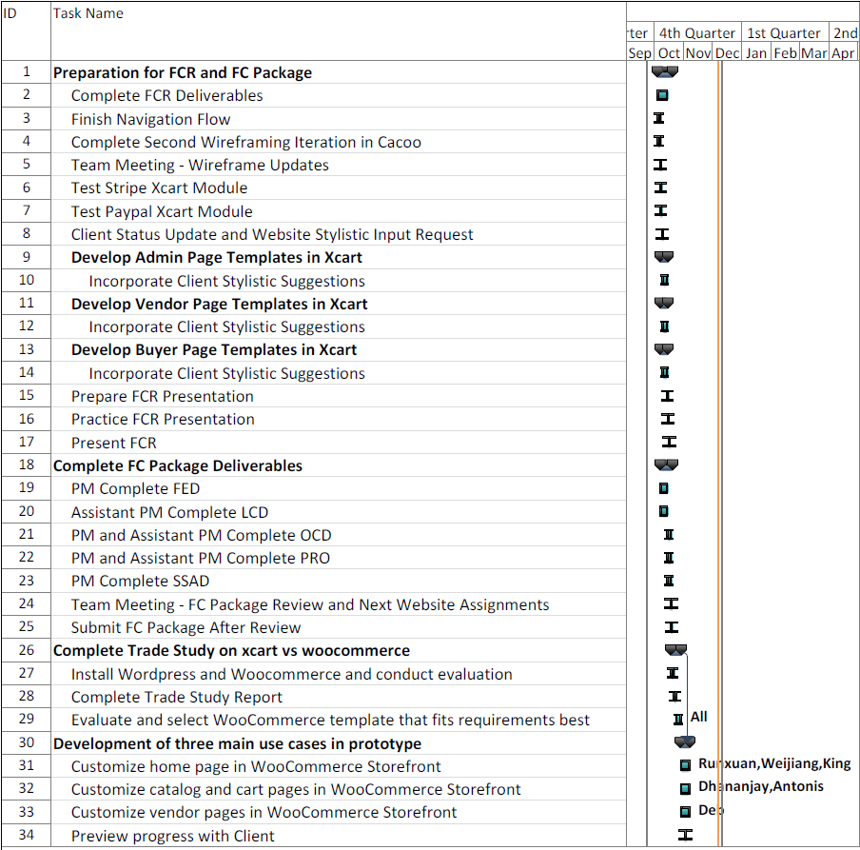

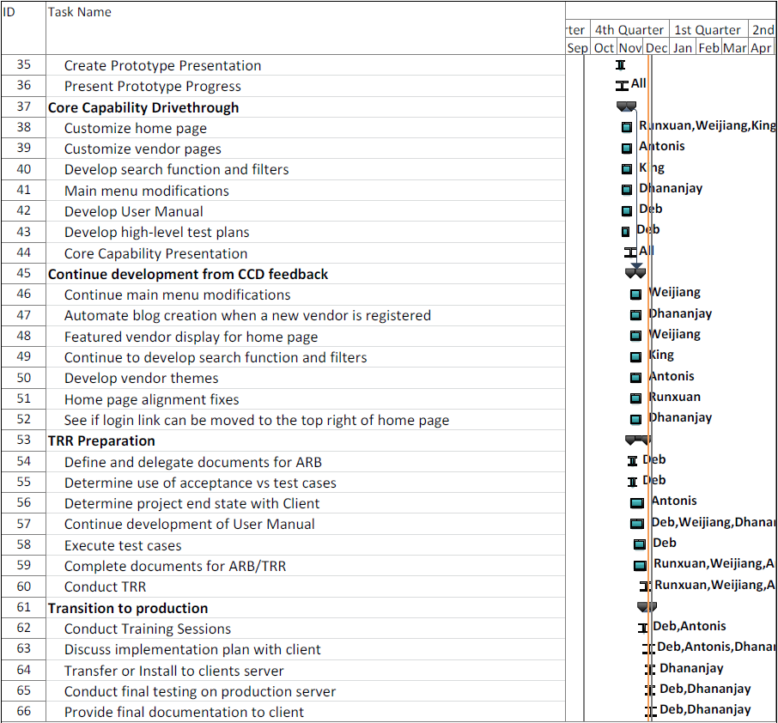

Responsibilities

#### Project-specific stakeholder’s responsibilities

N/A

#### Responsibilities by Phase

Table 2: Stakeholder's Responsibilities in each phase

|  |  |  |  |
| --- | --- | --- | --- |
| **Team Member / Role** | **Primary / Secondary Responsibility** | | |
| **Exploration** | **Valuation** | **Foundations** |
| Dhananjay Nakrani | **Primary Responsibility**  develop prototype **Secondary Responsibility**  Come up Win-Win conditions | **Primary Responsibility**  Evaluate different prototype alternatives  **Secondary Responsibility**  Quality for both project and team processes & deliverables  GUI Prototype (XCart) admin main page | **Primary Responsibility**  Identify Risks relating to multivendor modules  Try out different COTS and analyze them  **Secondary Responsibility**  Quality for both project and team processes & deliverables |
| Runxuan Wei | **Primary Responsibility**  field observations **Secondary Responsibility**  develop prototype | **Primary Responsibility**  SSAD doc create and update  xcart setup and hello world page  **Secondary Responsibility**  buyer use case development | **Primary Responsibility**  analyze payment method risk with multivendor  **Secondary Responsibility**  assistant in group documents and report |
| Deb Baker | **Primary Responsibility**  Facilitate in WinWin negotiation  Quality for both project and team processes & deliverables  **Secondary Responsibility**  field observations | **Primary Responsibility**  Quality for both project and team processes & deliverables  **Secondary Responsibility**  Identify project risk | **Primary Responsibility**  Quality for both project and team processes & deliverables  **Secondary Responsibility**  Identify project risk |
| Weijiang Dang | **Primary Responsibility**  Initial user interface  **Secondary Responsibility**  Contact with the client | **Primary Responsibility**  Customer’s ware framing **Secondary Responsibility**  Identify project risk | **Primary Responsibility**  Develop Prototype of XCart **Secondary Responsibility**  Improve Prototype |
| King Lun Au | **Primary Responsibility**  field observations  come up Win-Winconditions  **Secondary Responsibility**  Initial user interface | **Primary Responsibility**  identify project risk  buyer user case development  **Secondary Responsibility**  develop prototype (X-cart) | **Primary Responsibility**  LCP documentation  **Secondary Responsibility**  Identify project risk |
| Antonis | **Primary Responsibility**  Contact with the client  **Secondary Responsibility**  Identify project’s risk | **Primary Responsibility**  Vendor Case Wire framing  **Secondary Responsibility**  GUI Prototype vendor main page | **Primary Responsibility**  Prepare OCD documentation  **Secondary Responsibility**  Identify Risks relating to multivendor modules |
| Client | **Primary Responsibility:** Engage in conversation with dev. Team about project vision | **Primary Responsibility:** Discuss win conditions with team negotiate risk and costs | **Primary Responsibility:** Provide feed back to the team regarding website appeal and GUI interface |

|  |  |  |
| --- | --- | --- |
| **Team Member / Role** | **Primary / Secondary Responsibility** | |
| **Development-** Construction Iteration | **Development-** Transition Iteration |
| Dhananjay Nakrani | **Primary Responsibility**  Multi-Site to achieve Multi-Vendorfunctionality.  Automated blog creation Customized theme a little  **Secondary Responsibility**  Tested functionality  Maintained Team Website | **Primary Responsibility**  **Secondary Responsibility** |
| Runxuan Wei | **Primary Responsibility**  Create and Maintain SSAD documentation **Secondary Responsibility**  Changed CSS for website front page  Research for payment tool | **Primary Responsibility**  **Secondary Responsibility** |
| Deb Baker | **Primary Responsibility**  Facilitate in WinWin negotiation  Quality for both project and team processes & deliverables  **Secondary Responsibility**  field observations | **Primary Responsibility**  **Secondary Responsibility** |
| Weijiang Dang | **Primary Responsibility**  Create short code for displaying featured vendor  **Secondary Responsibility**  Change CSS for website front page  Adding plugin for user avatar | **Primary Responsibility**  **Secondary Responsibility** |
| King Lun Au | **Primary Responsibility**  Develop search function and filter  Create and Maintain LCP documentation **Secondary Responsibility**  Customize home page in WooCommerce Storefront | **Primary Responsibility**  **Secondary Responsibility** |
| Antonis | **Primary Responsibility**  OCD Documentation  Bi-weekly reports,  Client interaction and meetings  **Secondary Responsibility**  UI improvements  Backup functionality | **Primary Responsibility**  **Secondary Responsibility** |
| Client | **Primary Responsibility:** Engage in conversation with dev. Team about project vision  Provide feedback and recommendation | **Primary Responsibility:** Read and understand the manual, provide recommendation for transition |

#### Skills

>>

|  |  |  |
| --- | --- | --- |
| **Team members** | **Role** | **Skills** |
| Dhananiay Nakrani | Developer, System Integrator, Team Website Admin | PHP, python, LAMP Stack, Flask, Rails (a bit), Bootstrap, jQuery, Wordpress |
| Runxuan Wei | Dev/system integrator | PHP, JavaScript, AJAX, MySQL, Python, JQuery |
| Deb Baker | QFP (Team/Web Req)/Assistant PM/ Team Website Admin | HTML, Java, C++, DBs, Javascript, vbscript |
| Larry Stratton | PM/QFP (Web Req)/Dev | PHP, Javascript, AJAX, jQuery, Bootstrap, some rails, Apache, MySQL, Wordpress, Java, C++ |
| Weijiang Dang | QFP (Web Req)/Dev | JAVA, C, C++, javascript |
| King Lun Au | QFP (Web Req)/Dev | Java, javascript, C++, C, Matlab, Python |
| Antonis Papantoniou | Sys/can dev when needed | Python, Javascript Frameworks:None |

Approach

#### Monitoring and Control

For monitoring purposes and control the team is using bi-weekly progress reports which are uploaded at the team website. Additionally weekly tasks are divided and tracked between the team members using slack.

##### Closed Loop Feedback Control

In terms of feedback between individual tasks we are having multiple Slack meetings per week to accommodate our DEN members and also document our discussions. In the meetings we present our respective progress and monitor the document status using Google docs and Bitbucket for code reviews and staying updated on code status. Finally all work is logged in to Jira to gauge each team member’s individual contribution to the project.

##### Reviews

Each task is usually divided between multiple teammates. This method allows each teammate to peer review the work of another to get feedback and ensure good work quality. Documentation is also reviewed by the PM and the assistant PM for final editing before submission.

#### Methods, Tools and Facilities

|  |  |  |
| --- | --- | --- |
| **Tools** | **Usage** | **Provider** |
| WordPress | Blog management | Wordpress.com |
| BitBucket | Code reviews and staying updated on code status | Atlassian Inc. |
| Amazon EC2 | Test deployment | Amazon.com |
| Slack | Communication and team meeting | Slack.com |
| Jira | Team project management and checking progress | Atlassian Inc. |

### Resources

Identify the following information in order to estimate the software cost:

* Estimated CSCI577a Effort : 6 team members at 12 hrs/week for 12 weeks
* Estimated CSCI577b Effort : 6 team members at 12 hrs/week for 12 weeks
* Total estimated effort = unknown
* Budget information = $0
* Project duration = 12 weeks
* Component modules in your development project = E-commerce tool, multi-vendor support, payment methods, search, blog posting, forums, database, web server
* Programming language used = php

For this effort, we used COCOMO II.2000.4. All drivers not specified below are considered “Nominal”.

Table 3: COCOMOII Scale Driver

|  |  |  |
| --- | --- | --- |
| **Scale Driver** | **Value** | **Rationale** |
| PREC | Low | System is widely used, but new to development team |
| FLEX | Low | Requirements are on the more specific end |
| RESL | Low | Using established platforms should eliminate larger design problems |
| TEAM | Low | Team cohesion is lacking and introduces risk |
| PMAT | Nominal | SEI CMM process maturity rating is poor |

Table 4: COCOMOII Cost Driver for modules “e-commerce” and “multi-vendor”

|  |  |  |
| --- | --- | --- |
| **Cost Driver** | **Value** | **Rationale** |
| APEX | Low | Only a few members of the team have experience developing applications |
| LTEX | Low | Only two members of the team are experienced developers |
| TOOL | Low | The MVC and e-commerce platforms introduce a new environment to the team – lack of experience is significant |

COCOMOII Cost Driver values for modules **“blog”** and **“forums”** was determined to be nominal.

Overall COCOMO Result:

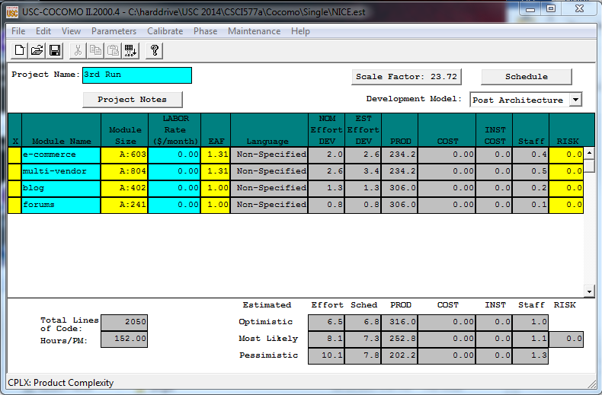

Based on this estimate, 8.1 person months is required to do the work, with a staff of 1.1 persons for 7.3 months. In the case of CS577, this estimate is reduced to 4.86 person months based on a 6 person team. Therefore, it is estimated that our team can complete the project on time.

The following are the individual module inputs based on Adaptation and Reuse of existing code.

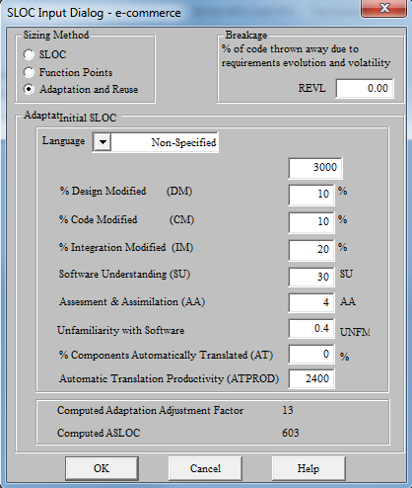 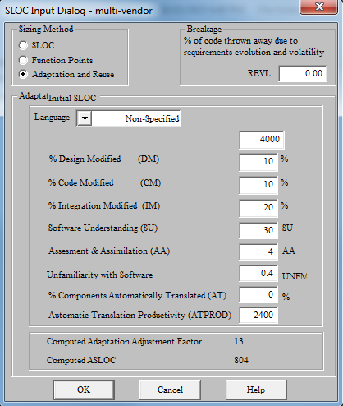

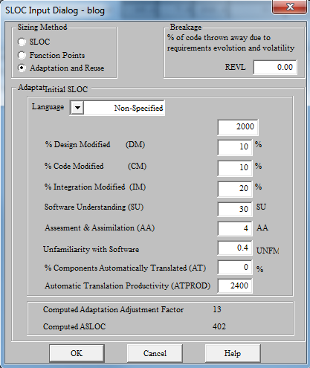 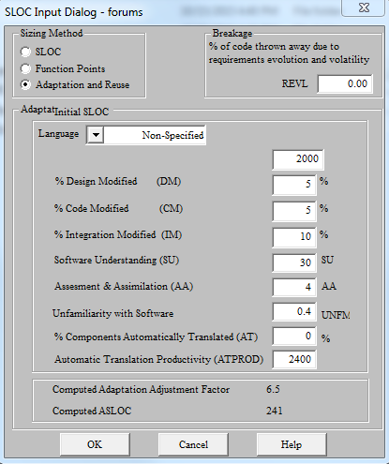

# 6. Iteration Plan

## 6.1 Plan

This Iteration Plan is intended to accomplish the major features and described the detailed plans for the iteration of this E-commence project. In the Iteration plan, the requirements would be further analyzed. Due to the fact that it is a one semester project, the team has prioritized list of objectives to work on. There are two iterations to implement the capabilities. The first iteration is to finalize the features that already included in the original WordPress. The second iteration is to edit and modify the existing Plugin and codes to accomplish the project requirements. The analysis and design for all use cases selected were completed. The architectural prototype were developed to test the feasibility and performance of the architecture that is required for the E-commence website.

### 6.1.1 Capabilities to be implemented

Table 13: Construction iteration capabilities to be implemented

|  |  |  |  |  |
| --- | --- | --- | --- | --- |
| ID | Capability | Description | Priority | Iteration |
| UC4 | Vendor can register for account | Check if the vendor can successfully create a new account. | M | 1 |
| UC8 | Add new product | Check if the vendor can successfully add a product. | M | 1 |
| UC7 | Edit existing product | Check if the vendor can successfully edit a product. | M | 1 |
| UC12 | View products | Check if a user can view a specific product. | M | 1 |
| UC12 | Search function | Check if a user can search a specific product. | M | 2 |
| UC13 | View orders | Check if a user can view his or her order. | M | 1 |
| UC6 | Checkout or purchase product | Check if a user can check out after he or she finish purchasing. | M | 1 |
| UC10 | Vendor can create a blog | Check if a vendor can create his or her own blog. | M | 2 |
| UC10 | Vendor can edit a blog | Check if a vendor can edit a specific product. | M | 2 |
| UC3 | Customer can create account | Check if a user can create a new account. | M | 1 |
| UC14 | Approve pending vendor | Check if an admin approve a new vendor. | M | 1 |
| UC1 | Login | Check if the user can login successfully | S | 1 |
| UC2 | Logout | Check if the user can logout successfully | S | 1 |
| UC5 | Add item to cart | Check if the user can add items into shopping cart. | M | 1 |
| UC9 | Delete product | Check if the user can delete items from the shopping cart. | M | 1 |
| UC11 | Write feedback on vendor | Check if the user can write feedback for specific vendor. | M | 2 |
| UCxx | Write feedback on products | Check if the user can write feedback for specific product. | M | 2 |
| UCxx | Approve pending product | Check if the admin can approve pending. | M | 1 |
| UCxx | Customer can signup for newsletter | Check if the user can subscribe the newsletter. | M | 2 |
| UCxx | Admin can create and email newsletter | Check if the admin can create and email in newsletter. | M | 2 |
| UCxx | Customer can subscribe to alerts | Check if the user can subscribe to alerts. | M | 2 |
| UCxx | Create discount coupons | Check if the system can create discount for the products. | S | 2 |
| UCxx | Customer can get recommendation based on questions | Check if the user can receive recommendation based on questions and their past purchasing history. | M | 2 |
| UCxx | Manage account settings | Check if the any user can manage and make change to the account settings. | S | 1 |
| UCxx | Delete item from cart | Check if the user can delete items from the cart. | M | 1 |
| UCxx | Edit quantity of item in cart | Check if the user can edit the quantity of item in cart. | M | 1 |
| UCxx | Admin can post site-wide communications and blogs | Check if the admin can post site-wide communication and blogs in his or her personal page. | M | 2 |
| UCxx | Admin can email vendors | Check if the admin can send email to the vendors. | S | 1 |
| UCxx | Admin can display vendors by sales and transactions | Check if the admin can display and sort the vendors by sales and transactions. | M | 1 |
| UCxx | Admin can suspend vendor accounts | Check if the admin can suspend a specific vendor account. | M | 1 |

### 6.1.2 Capabilities to be tested

Table 14: Construction iteration capabilities to be tested

|  |  |  |  |  |
| --- | --- | --- | --- | --- |
| ID | Capability | Description | Priority | Iteration |
| UC4 | Vendor can register for account | Check if the vendor can successfully create a new account. | M | 1 |
| UC8 | Add new product | Check if the vendor can successfully add a product. | M | 1 |
| UC7 | Edit existing product | Check if the vendor can successfully edit a product. | M | 1 |
| UC12 | View products | Check if a user can view a specific product. | M | 1 |
| UC12 | Search function | Check if a user can search a specific product. | M | 2 |
| UC13 | View orders | Check if a user can view his or her order. | M | 1 |
| UC6 | Checkout or purchase product | Check if a user can check out after he or she finish purchasing. | M | 1 |
| UC10 | Vendor can create a blog | Check if a vendor can create his or her own blog. | M | 2 |
| UC10 | Vendor can edit a blog | Check if a vendor can edit a specific product. | M | 2 |
| UC3 | Customer can create account | Check if a user can create a new account. | M | 1 |
| UC14 | Approve pending vendor | Check if an admin approve a new vendor. | M | 1 |
| UC1 | Login | Check if the user can login successfully | S | 1 |
| UC2 | Logout | Check if the user can logout successfully | S | 1 |
| UC5 | Add item to cart | Check if the user can add items into shopping cart. | M | 1 |
| UC9 | Delete product | Check if the user can delete items from the shopping cart. | M | 1 |
| UC11 | Write feedback on vendor | Check if the user can write feedback for specific vendor. | M | 2 |
| UCxx | Write feedback on products | Check if the user can write feedback for specific product. | M | 2 |
| UCxx | Approve pending product | Check if the admin can approve pending. | M | 1 |
| UCxx | Customer can signup for newsletter | Check if the user can subscribe the newsletter. | M | 2 |
| UCxx | Admin can create and email newsletter | Check if the admin can create and email in newsletter. | M | 2 |
| UCxx | Customer can subscribe to alerts | Check if the user can subscribe to alerts. | M | 2 |
| UCxx | Create discount coupons | Check if the system can create discount for the products. | S | 2 |
| UCxx | Customer can get recommendation based on questions | Check if the user can receive recommendation based on questions and their past purchasing history. | M | 2 |
| UCxx | Manage account settings | Check if the any user can manage and make change to the account settings. | S | 1 |
| UCxx | Vendor can email customer | Check if the vendor can email the user. | S | 1 |
| UCxx | Delete item from cart | Check if the user can delete items from the cart. | M | 1 |
| UCxx | Edit quantity of item in cart | Check if the user can edit the quantity of item in cart. | M | 1 |
| UCxx | Admin can post site-wide communications and blogs | Check if the admin can post site-wide communication and blogs in his or her personal page. | M | 1 |
| UCxx | Admin can display vendors by sales and transactions | Check if the admin can display and sort the vendors by sales and transactions. | M | 1 |
| UCxx | Admin can suspend vendor accounts | Check if the admin can suspend a specific vendor account. | M | 1 |

### 6.1.3 Capabilities not to be tested

Most capabilities were tested in order to check if the features of the website can operate properly.

For example, the capabilities of WooCommerce and WC vendors were tested. However, the team did not do load testing because there was no high load requirements.

### 6.1.4 CCD Preparation Plans

In CCD, the clients would test and implement the features from WordPress in their local machine. A user manual that outlined all the test cases, was sent to the clients. The clients can go through them on their own. Following from the manual steps by steps, the clients would experience the current system. Meanwhile, the team would have a computer for dry run simultaneously along with the clients. When the clients were confused, they can come back to us with any concerns or feedback, and we can answer their question instantly. Feedback forms would be used in order to record the problems and comment from the clients. The feedback is highly important because the team would need that information for further risk analysis. It can reduce the risks, and provide a better user experience in the future development.

## 6.2 Iteration Assessment

### 6.2.1 Capabilities Implemented, Tested, and Results

Table 15: Capabilities implemented, tested, and results

|  |  |  |  |  |
| --- | --- | --- | --- | --- |
| **ID** | **Capability** | **Test Case** | **Test Results** | **If fail, why?** |
| UC4 | Vendor can register for account | TC-01 | Pass | N/A |
| UC8 | Add new product | TC-02 | Pass | N/A |
| UC7 | Edit existing product | TC-03 | Pass | N/A |
| UC12 | View products | TC-04 | Pass | N/A |
| UC12 | Search function | TC-05 | Pass | N/A |
| UC13 | View orders | TC-06 | Pass | N/A |
| UC6 | Checkout or purchase product | TC-07 | Pass | N/A |
| UC10 | Vendor can create a blog | TC-08 | Pass | N/A |
| UC10 | Vendor can edit a blog | TC-09 | Pass | N/A |
| UC3 | Customer can create account | TC-10 | Pass | N/A |
| UC14 | Approve pending vendor | TC-11 | Pass | N/A |
| UC1 | Login | TC-12 | Pass | N/A |
| UC2 | Logout | TC-13 | Pass | N/A |
| UC5 | Add item to cart | TC-14 | Pass | N/A |
| UC9 | Delete product | TC-15 | Pass | N/A |
| UC11 | Write feedback on vendor | TC-16 | Pass | N/A |
| UCxx | Write feedback on products | TC-17 | Pass | N/A |
| UCxx | Approve pending product | TC-18 | Pass | N/A |
| UCxx | Customer can sign up for newsletter | TC-19 | Pass | N/A |
| UCxx | Admin can create and email newsletter | TC-20 | Pass | N/A |
| UCxx | Customer can subscribe to alerts | TC-21 | Pass | N/A |
| UCxx | Create discount coupons | TC-22 | Pass | N/A |
| UCxx | Customer can get recommendation based on questions | TC-23 | Pass | N/A |
| UCxx | Manage account settings | TC-24 | Pass | N/A |
| UCxx | Delete item from cart | TC-26 | Pass | N/A |
| UCxx | Edit quantify of item in cart | TC-27 | Pass | N/A |
| UCxx | Admin can post site-wide communications and blogs | TC-28 | Pass | N/A |
| UCxx | Admin can email vendors | TC-29 | Pass | N/A |
| UCxx | Admin can display vendors by sales and transactions | TC-30 | Pass | N/A |
| UCxx | Admin can suspend vendor accounts | TC-31 | Pass | N/A |

### 

### 6.2.2 Core Capabilities Drive-Through Results

The overall CCD was successfully, the clients left positive feedback and they were comfortable with most of the features. For instance, clients where able to intuitively login as a vendor, create and delete products from the cart or add new products to the catalog. This is an indication that the user interface remains intuitive despite the multitude of features that are included.

Nevertheless, there are improvements that can be done in future development. Home page login can be placed a bit better the same for the search function. Some more complicated admin tasks are not as intuitive for the non-tech savvy person, and thus the training manual will focus a lot on them with detailed descriptions and screenshots.

Some changes that can be considered are as following. For the admin to approve a product, the clients felt that is too complicated because they had to click on the product to show the details, and then approve that specific product. After, they did not know how to go back to the list. The meaning of “pending” and the back button would need to explain during the session. The possible issues were when the clients saw the list of items to be approved and clicked to see the details, if they wanted to go back to the list of items, during CCD the user needed to click at the menu to go back to the list. Therefore, this action would redirect users to the first page of the item lists. However, it is possible that clients were looking at some other pages (e.g. page #5). It would be easier for the clients if they can go back to the page that they were looking.

When the clients tried to make purchase by adding to the cart and paying with an ordering page, they had a difficulty. It was hard for them to find the “shop” link. The checkout button, which is at the bottom of the screen, should consider to be relocated to the top of the screen so that clients did not have to scroll down to the bottom of the screen every time they make a purchase. In addition, the order Icon in the left menu was a gear icon, the team should find a new icon that give more intuitive.

A potential risk could be from the case of suspending a vendor. First, clients had some problems in finding logging link. Second, clients went into the super administrator, instead of the administrator of the website. In order to mitigate these risks, the training manual should provide a detailed explanation, including with screenshot.

## 6.3 Adherence to Plan

The iteration is currently doing well according to the initial plan. The team has finished the work on schedule without extra labor cost. The only uncertainty in the Software Development Status is that the team needs to customize and modify the co-existing front page to meet the expectation of clients matching feedback from the client/team meetings. Such changes must be made carefully so the whole functionality of the website is not affected as this is the end of the semester and there is not much time to recover from potential problems that may arise.